РГПУ им. А.И. Герцена

Тема «Методы решения сетевых задач»

Семенов Л.А. 2ИВТ, 1 группа, 2 подгруппа

Задача 1.

Найти минимальный остов дерева представленного графа:

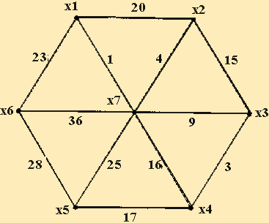

|  |  |  |  |  |  |  |  |
| --- | --- | --- | --- | --- | --- | --- | --- |
|  | x1 | x2 | x3 | x4 | x5 | x6 | x7 |
| x1 |  |  |  |  |  |  |  |
| x2 | 20 |  |  |  |  |  |  |
| x3 |  | 15 |  |  |  |  |  |
| x4 |  |  | 3 |  |  |  |  |
| x5 |  |  |  | 17 |  |  |  |
| x6 | 23 |  |  |  | 28 |  |  |
| x7 | 1 | 4 | 9 | 16 | 25 | 36 |  |

Ответ: вес минимального остова равен 23+1+4+9+3+17 = 57.

Задача 2.

Найдите кратчайший путь на представленном графе:

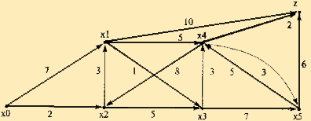

Решение:

|  |  |  |  |  |  |  |  |
| --- | --- | --- | --- | --- | --- | --- | --- |
|  | x0 | x1 | x2 | x3 | x4 | x5 | Z |
| x0 |  | 7 | 2 |  |  |  |  |
| x1 |  |  |  | 1 | 5 |  | 10 |
| x2 |  | 3 |  | 5 |  |  |  |
| x3 |  |  |  |  | 3 | 7 |  |
| x4 |  |  | 8 |  |  | 3 | 2 |
| x5 |  |  |  |  | 5 |  | 6 |
| Z |  |  |  |  |  |  |  |

|  |  |  |  |  |  |  |  |
| --- | --- | --- | --- | --- | --- | --- | --- |
|  | x0 | x1 | x2 | x3 | x4 | x5 | Z |
| x0 |  | 7 | 2 |  |  |  |  |
| x1 |  |  |  | 1 | 5 |  | 10 |
| x2 |  | 3 |  | 5 |  |  |  |
| x3 |  |  |  |  | 3 | 7 |  |
| x4 |  |  | 8 |  |  | 3 | 2 |
| x5 |  |  |  |  | 5 |  | 6 |
| Z |  |  |  |  |  |  |  |

Ответ:

Кратчайший путь x0 -> x2 -> x3 -> x4 -> Z.

